[Lina M. Ashour]
Contact address: Amman- Jordan
e-mail: ashourlina@hotmail.com | Mobile no: +962-79-5631102|
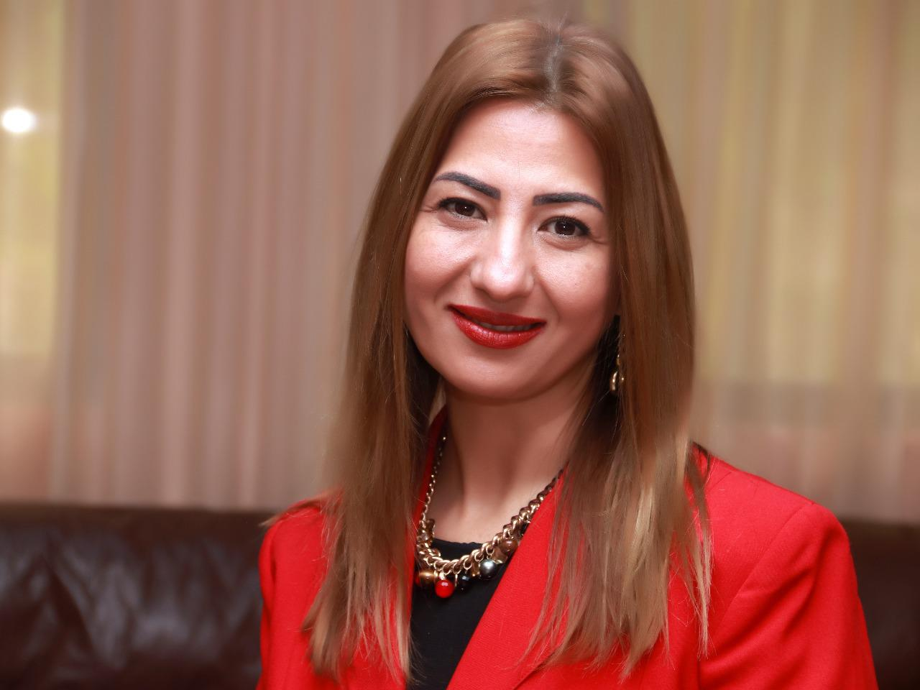
Academic Qualification
- 2012 – University of Jordan, Amman – Jordan
PhD in Educational & Psychological Counseling

- 1997 – University of Jordan, Amman – Jordan
M.A. in Educational & Psychological Counseling

- 1994 – University of Jordan, Amman – Jordan
B.A. in Counseling & Mental Hygiene

Work Experience
- 2013 – Current, Philadelphia University – Jordan, Head of psychological counseling department- assistant professor.
Key Responsibilities
- To contribute to the formation of strategy and plans at Faculty level, through engagement with the Dean, Associate Deans and Faculty colleagues, environment scanning and assessment of opportunities and risks
- To ensure delivery of the Department’s contribution to University and Faculty strategic plans.
- To support and develop academic leadership in the department and wider community.
- Effective management of all staff in the Education and Research job family, plus other staff as delegated by the Dean, through the establishment and operation of an effective Departmental leadership team
- Appropriate and effective management of the Departmental budgets
- Management of the Department’s physical estate as appropriate, in collaboration with the Faculty.
- Ensuring that Health, Safety and Environmental practice in the Department complies with University policy and regulations
- Ensuring effective representation of the Department’s interests within and outside the University
- Ensuring that the activities of the Department are undertaken in accordance with the governance, policy and regulatory frameworks of the University
- Teaching under graduate subjects.
- Supervision and guidance for under graduate students.
- 2010 – Current, Jordan- Psychological Therapist.
Key Responsibilities

-Working with individuals, couples, families and groups in orders to overcome a range of psychological and emotional issues, using personal treatment plans and a variety of non-medical-based treatments.

- Networking within the health professional community, and other potential business areas, to maintain continuity of work and client base

- Evaluating therapy outcomes and writing reports

- 2009 – 2013, Center for Victims of Torture (CVT) Jordan- Psychosocial Counselor supervisor.
Key Responsibilities
- Providing clinical supervision for counselors

- Providing individual and group counseling for vulnerable refugees both Iraqis and Syrians inside community.
- Communicating with other humanitarian NGO’s and cooperating in case referral manner

- Capacity building for CBOs through trainings and follow-ups

- Case management and advocacy for vulnerable population

- Material and assessment tools development

- Making psychological assessments.

- 2008 – 2009, Freelance Trainer and lecturer:

Provide private and public training sessions and workshops for soft skills & behavioral modification for individuals and groups, through out different aeries in Jordan (Amman, Zarqa, Erbid and Aqaba).

- 1998 – 2008, Rawdat Al-Ma'aref Schools & College, Jordan- Head of Counseling Department
Key Responsibilities

-Delivering psychology counseling for students in classes and personnel.
-Tailoring and delivering educational programs for students, their families, and the staff.
-Educational lectures organizer for students and staff exchange.
-Collecting and delivering humanitarian aid to refugee camps.
-Carrier guiding for students through carrier weeks, lectures visits exchange.
-Counseling teaching and training to the undergraduate and graduate students from different universities in Jordan.

- 1994 – 1998, Amman Academy School, Jordan- Instructor
Key Responsibilities
-Teaching mathematics, social studies, English and organizing activates to enhance and develop pupil’s personality.

-Tutoring for English native speaker families (ranged 6-30 years old)

-Tutoring mathematics, science, Arabic, social studies, and religion

- 1997 – 2004, University of Jordan- Teaching Assistant in Faculty of Educational Sciences- Jordan university.

Special Experience
- Licensed practitioner in mental health from the ministry of health.
- Founder member of the Arabic union for psychological sciences.
- 2007-Now board committee (Jordanian Psychology Association).
- 2001-2007 Jordanian Psychology Association-Vice President.
- 2002-2003 Ministry of Education: A booklet was issued in Carrier Guidance as a result of my participation in the working counselor team.
- A member of M.A dissertation Defend committees of Amman Arab University.
- Member of practice certificate exam committee for mental health practitioners at ministry of health – Amman- Jordan.
- Member of simulating treatment for addiction with cooperation with Jorden psychological association and public security department.
- Member of the preparing committee for art faculty annual conference at Philadelphia university (2014- 2021).
- Member of the scientific committee for the social responsibility conference at Amman Arab University 2019.
- Key note speaker at many virtual conferences (2020-2021).

Key Skills
- Improve projects deliverables through strengthening and constructing new approaches (designing new therapeutic approach of family and couple support-started in 2010 in CVT till current)
- Team building skills
- Problem solving & decision making.
- Self, people and service management.
- Public speaking.
- Special events managements and activities/campaigns organizing.
- Excellent personal relations in a wide variety of private and public sectors.
- Customer care, soft skills and positive thinking training for individuals and groups.
- Guiding individuals with behavioral problems
- Talk show consultant in TV & radio
- Anger management trainer
- Music therapist
- Trauma therapy trainer
- Leadership trainer

Certifications
- Licensed to practice counseling therapy from the ministry of health.
- ICDL certified.
- TOT in Human Recourses.
- TOT for the Humanitarian sector.
- EMDR practitioner

Professional Training
- 2012Trainer provider in Aqaba, Zarqa, Amman, Irbid.
- 2012 Training for Trainers (4 working days)/Red R UK.
- 2011 Narrative Exposure Therapy (3 working days)/Centre for Victims of Torture (CVT)
- 2010 Five Steps to Tactical Innovation (3 working days)/New Tactics in Human Rights-CVT
- 2010 The International Congress of Psychiatry (3 working days)/Psychiatrists Allied Professionals
- 2009 “Positive thinking and personality types”
- 2009 Lecturer, Amman/“Human development”
- 2009 Training in “Decision making and problem solving”/University of Jordan
- 2009 Organizing committee member of scientific Conference of the Jordanian Psychological Association"
- 2001 Oral Presentation in the educational conference "Decision Making”/ Rawdat Al-Ma'arf Schools & Collage
- Many other lectures and workshops in private and public sectors about human behavior modification, human development and soft skills.

Languges & Computer Skills
- Arabic: Mother Tongue.
- English: Excellent Reading, writing & speaking.
- Computer literary with knowledge of MS windows, MS office, and Internet.

Publication
- The Effect of Couples Conseling Program on Improving Marital Adjustment & Decreasing post-Traumatic Stress Disorder Among Iraqis Immigrants in Jordan.
- Anxiety Disorders Among Jordanian Youth : From Behavioral Cognitive Perspective.
- Ashour,lina. Abbass,lina. Halaseh, hannan.,the prevalence of Paranoid Personality symptoms and gender differences among university students. Dirasat: Educational Sciences . 2018 Supplement, Vol. 45, p553-565. 13p.
- Qadan, firas. Ashour,lina, The role of Psychological guidance and counseling in achieving intellectual security in the light of the repercussions of the phenomenon of terrorism and extremism from the point of view of the Educational counselors in the capital Amman. journal of american academic research
- Almajali, salwa. Ashour,lina,.The Negative Consequences of Poor Emotion Management (Anger, Anxiety and Frustration) on The Brain and Body. Talent Development & Excellence, Vol.12, No.2s, 2020,3410-3419
- Abdel Hadi, S., Ashour, L., Kamour, M. (2021). Interpersonal sensitivity among sample of university students and its relationship to impulsivity in light of gender, specialization and academic year variables. Pending

References
- Upon Request

